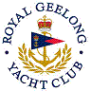 | Royal Geelong Yacht Club Inc.  Est 1859
Trophy Deed of Gift.

Trophy: | Master Builders’ Ass’n Geelong Trophy for Twilight Race
Presented by:
Date: | 1993
For: | Div 1 Twilight Race Winner of Event so Nominated
Remarks / Revisions
Click here for a List of Recipients

